**DESIGNED & RECREATED AGENCY CONTACT PAGE**

**Aim**

To design an intuitive and visually appealing contact page for an agency that enhances user experience and facilitates easy communication with potential clients.

**Procedure**

1. **Research and Analysis**: Reviewed existing contact pages from similar agencies to identify key features and design elements.
2. **Wireframing**: Created basic wireframes to outline the structure and layout of the contact page.
3. **Design Development**: Developed detailed designs in Figma, incorporating branding elements, user-friendly forms, and clear call-to-actions.
4. **Prototyping**: Built an interactive prototype in Figma to simulate user interactions and gather feedback.

**Prototype**

* **Layout**: Includes sections for contact information, a contact form, a map, and social media links.
* **Design Elements**: Utilized consistent typography, color schemes, and iconography aligned with the agency’s branding.
* **Interactions**: Enabled clickable elements to demonstrate functionality, such as form submissions and map interactions.

**Result**

The redesigned contact page provides a clean, modern interface that improves usability and encourages user engagement. Feedback from stakeholders was positive, highlighting the page’s ease of use and alignment with the agency’s brand identity.

BEFORE

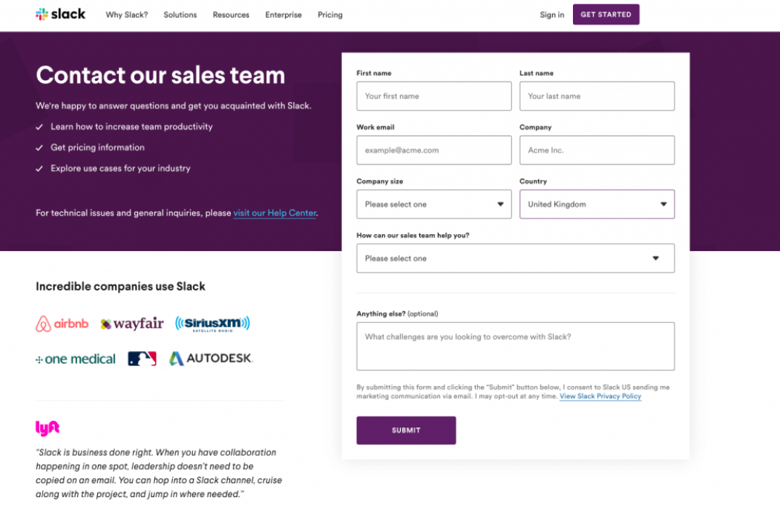

AFTER